PAINTING COURSE FOR HOBBYIST PORCELAIN PAINTERS
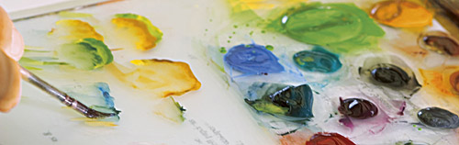

Few people can boast of ever having painted porcelain… Herend is the place to make your dream come true. Our painting courses will guide the participants through the principal phases of porcelain painting. We look forward to receiving your application!

Venue: Minimanufactory’s creative workshop

Our program offer:
9.00 Painting seminar
10.00 Coffee break at the Apicius Café
10.15 Painting seminar
12.00 Lunch time
13.00 Painting seminar
14.00 Coffee break at the Apicius Café
Side programs: Visiting the Porcelain Museum and the Minimanufactory at the Porcelanium Visitor Centre. Shopping at the Victoria Brand Shop having the largest selection of fine Herend porcelain.
15.30 Painting seminar
16.00 Handover of the Memorial Certificate

Herend Porcelain Manufactory is offering art lovers painting seminars in which they can realize their own artistic potential on porcelain. There are seminars for both beginners and those with previous painting practice and they will be run by experienced master instructors and artists of the Herend Porcelain Manufactory.
One-day course fee: 60 000 HUF per person

The course fee covers the following range of services:
- Introduction to artistic decoration, explanation and initiation of stages in the porcelain painting process
- Provision of the painting utensils required, such as paint, oil, brushes
- A self-painted piece of porcelain provided with unique trade mark of the Herend Painting Course including firing process, not including cost of delivery
- Coffee breaks, not including lunch menu
- Memorial Certificate

ACTIVITY SIGN-UP FOR THE HEREND PORCELAIN PAINTING COURSE

Attendee's name: …………………………………………………………
Address: …………………………………………………………
Telephone: …………………………………………………………
Email: …………………………………………………………
Your requested date for the painting course: …………………………………………………………
Chosen pattern: …………………………………………………………
Payment : by cash or credit card on the spot

Deadline for application: two weeks prior to starting the course.

